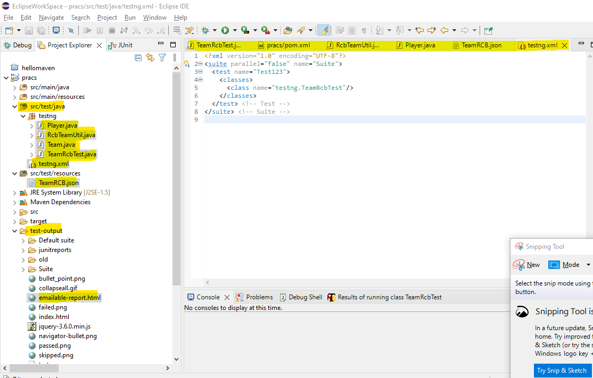

**Step 1#: Create Maven project in ECLIPSE.**

Add dependencies to the POM file: TestNG, RestAssured, jackson for JSON serialization/deserialization etc, as shown below:

<dependency>

<groupId>org.testng</groupId>

<artifactId>testng</artifactId>

<version>${testng.version}</version>

<scope>test</scope>

</dependency>

<dependency>

<groupId>io.rest-assured</groupId>

<artifactId>rest-assured</artifactId>

<version>4.3.0</version>

<scope>test</scope>

</dependency>

<dependency>

<groupId>com.fasterxml.jackson.core</groupId>

<artifactId>jackson-databind</artifactId>

<version>2.11.3</version>

</dependency>

**Step 2# Add files to the project as shown in the below path**

C:\EclipseWorkSpace\pracs\src\test\java\testng\

Player.java -- plain POJO

Team.java -- plain POJO

RcbTeamUtil.java -- UTIL class to perform API Testing

TeamRcbTest.java -- Test NG test class, to perform the

C:\EclipseWorkSpace\pracs\src\test\resources\

TeamRCB.json -- API Call RESPONSE as JSON text

C:\EclipseWorkSpace\pracs\src\test\java\testng.xml

**Step 3#: Build the Maven project and Run the Testcases**

TeamRcbTest.java as TestNG application

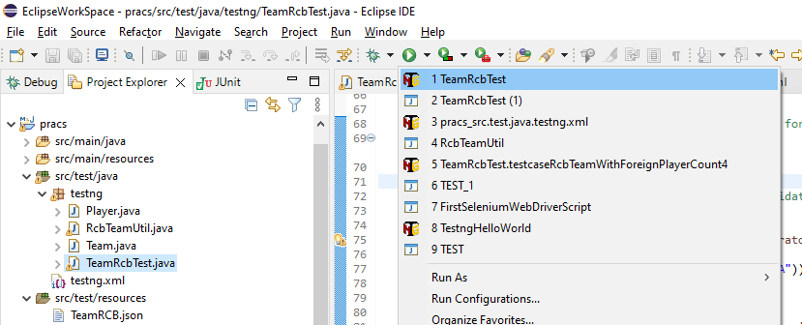

**Step 4#: The generated result is shown in emailable-report.html**

